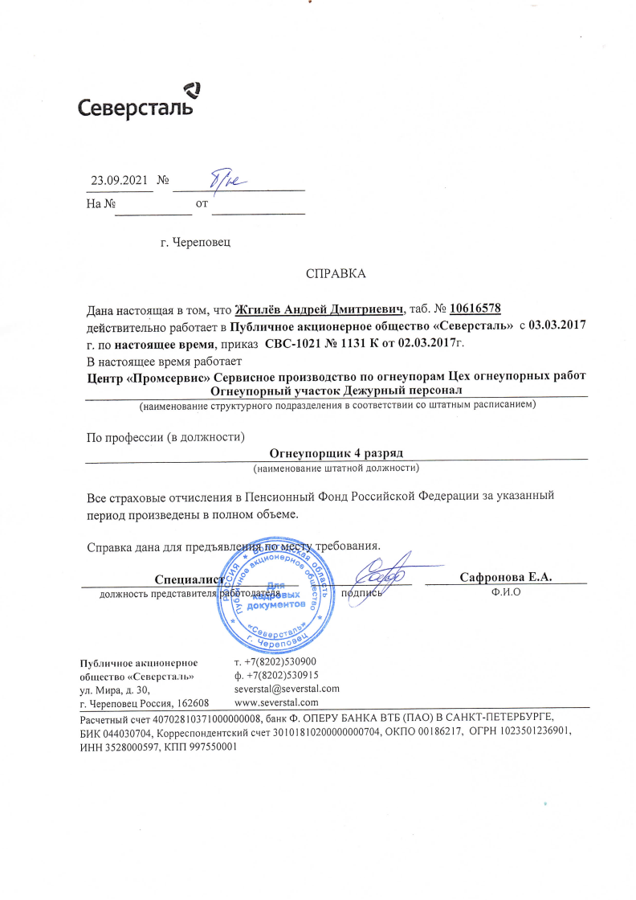
€1 CeBepcTaJib
T. +7(8202)530900
a). +7(8202)530915 severstal@severstal.com www.severstal.com
23.09.2021 N9 %
01.06.2022
Ha Ng OT
r. tlepelloBel]
CIIPABKA
HaHa HacTojlll|arl 8 TOM, qTo XrllureB AHHpefi HMHTplleBIIq, Ta6. N9 10616578 ;|e#cTBHTer[]iHo pa6oTaeT a Hy6j"qHoe aKI|IIOHepHoe o6uecTBo «CeBepcTajlb» c 03.03.2017 r, r[o HacToflH|ee BpeMfl, IIPHI(a3 CBC-102l Ng 11311{ oT 02.03.2017r.
a HacTojlll|ee BpeMjl pa6oTaeT
I|eHTP «IIpoMcepBIIc» CepBIICHoe npoH3BOHCTBo IIo orHeynopaM I|ex orHeyllopHblx pa6oT orHeyllopHblfi y.IacTOK HexypHbli± nepcoHaTI
(Ha"eHOBa"e cTpyl(TypHoro lioApa3AejleHMfl 8 cOOTBeTCTBHM cO iHTaTHb" pacr"caHHeM)
Ilo IIpodyeccHH (8 z|oJlxHoc")
orHeynopullK 4 pa3PflH
(HaHMeHOBa"e LHTaTHo# floJlxHoC")
Bce cTpaxoBble oTqllcJleHHfl 8 HeHclloHHI>Ifi ®oHH Poccl4#cKofi ®eziepai|HH 3a yKa3aHHI>I# IIepHOH IIPoll3BeHeHI>I a IIOJIHOM o6beMe.
Hy6jirlt+Hoeal(IilioLlc`p[ioc o6iiiecTBo «CcBc`pcTa.ii>» yJ,. MHpa' fl. 30'
1`. qeperloBeu PoccHfl,162608
PacqeTHI,I# ctleT 40702810371000000008, 6aHK a. OIIEPV BAHKA BTB (nAO) a CAHKT-rlETEPBVprE, BHK 044030704, KoppeclioHj|eHTCKH# cueT 30101810200000000704, OKrlo 00186217, OrpH 1023501236901, 14HH 3528ooo597, Kriri 99755oooi

